Additional Exercise on HTML5 and JavaScript

1. Write the HTML5 program to display the following using canvas tag. Give different colour for the rectangles.



1. Write a JavaScript program to compute the sum and product of an array of integers. Take the array elements from user. ( Use alert command )
2. Write a JavaScript conditional statement to sort any three numbers. Display an alert box to show the result.
3. Write a java script program to take some input from the user [string, integer and Boolean]. Based on the input, display the type of the input in the ‘text box’.
4. Write the HTML5 program to draw a “smiling face” picture using the canvas tag.
5. Write the JavaScript program to add items into the array and delete items from array using two methods.
6. Write the java script program to display the grade [A, B,C,D] based on the marks entered by student(take the input into text boxes). Enter the marks of 4 subjects and calculate the average( using button). If the avg>90 then A, avg>80 then B, if avg>70 then C, if avg>60 then D.
7. Write the JavaScript program to show the below output.

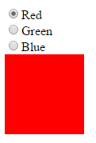

1. Write the HTML5 program to display following with validation to each field.

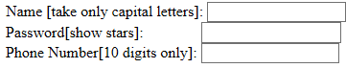

1. Write a JavaScript program to perform an online quiz.